Rania Mukahal 23110703
Nayef Abuageel
Abstract
This technical report will explore the potential for implementing an AI system at Al Haramain Hospital and its subsidiary Salma Medical Center. This AI system should improve operational efficiency and improve patient care, outcomes, and satisfaction. The study shows the impact, benefits, and purpose of implementing an AI diagnostics system in the medical sector.
Technical Report
AlHaramain Hospital / Salma medical center

Contents
1 Introduction 2
2 Organizational Study 3
2.1 Identify the organization 3
2.2 Features and the operational areas of the selected organization 3
2.3 Stakeholders 4
2.4 Challenges to the success of the organization's business 5
2.5 Business Requirements 6
3 Research Study 7
3.1 Research Overview 7
3.2 Analysis of Collected Data and Description of Generated Knowledge 8
3.3 Research Findings 10
4 References 11
5 Appendices 11

Introduction
Artificial Intelligence was a theory of interest from the late 19th century till the mid-20th century (1955) when the first AI system (Logic Theorist) was developed by Allen Newell and Herbert Simon. Nowadays, Artificial Intelligence is defined as a system that mimics human functions to perform common tasks, such as decision-making, web searching, problem-solving, and recognizing patterns in the data. It also helps develop intelligent machines and computer programs by relying on logic, algorithms, and large amounts of data to achieve the best outcomes. Examples include Siri, Alexa, Cortana, ChatGPT, and Gemini. These examples help with scheduling, setting reminders or alarms, and web searching. This report explores different AI systems that can be implemented in the healthcare sector, such as diagnostics, drug discovery, surgeries, management, scheduling, and many other systems.
Moreover, organizations that use AI systems rely on a variety of tools, applications, and technologies to implement and manage AI-driven solutions. Two tools are TensorFlow and Pytroch. TensorFlow is from Google and is the best option for building a variety of models, as it is also useful for machine learning and deep learning such as analysis, speech recognition, and image processing. However, PyTorch is a Python programming language that supports mathematical operations, and it is mostly used for research and artificial intelligence applications. This tool is flexible and easy to use with the programming language Python. TensorFlow may be suited for projects, but PyTroch is easier and lighter to work with, it is a good option to create prototypes and conduct research. AI can be applied in different sectors to help simplify complex tasks and help speed up processes that can use basic human intelligence. AI applications used in organizations include chatbots, and AI systems that help with analysis, security, and some other tasks. Some examples are applications include Notion which is used for personal organization, team collaboration, note-taking, and task tracking. AI technology refers to systems and processes that perform common tasks that require human intelligence, those technologies might include Google Vertex AI, AWS SageMaker, and Microsoft Azure.
Additionally, artificial intelligence can have an impact on the operational efficiency of different sectors. In the financial sector, AI can assist in the detection of fraudulent transactions as it can analyze those transactions to detect unusual patterns. It can also function as a virtual assistant to handle inquiries, process transactions, and make recommendations in a more efficient and faster way. Moreover, in the retail sector, AI can help analyze market conditions, and pricing of competitors, and set products to the optimal pricing to reach customer satisfaction. In addition, it can act as a recommendation system that improves the shopping experience by suggesting new products based on customers' historical purchases and preferences. Furthermore, In the academic sector, AI can track student progress and address their needs accordingly, this can aid in improving student knowledge and experience. Furthermore, virtual classrooms can also help support students with questions or inquiries that they might have which can increase the quality of the education they receive. During this report we are going to concentrate on the healthcare sector, and how AI impacts its operational efficiencies. AI can assist with the prevention, detection, diagnosis, and treatment of any disease. It can help medical professionals with decision-making processes and developing treatment plans for their patients as well as providing efficient and accurate imaging and monitoring of the patients. They also aid with repetitive tasks such as data entry and updating. AI can assist with challenges that usually require data analysis, studying treatment plans, and the detection of human errors.
In summary, this technical report will study the impact of an AI system by conducting primary and secondary research in Al Haramain Hospital and its subsidiary Salma Medical Center to understand people's resistance and knowledge about AI. This report will help us understand how AI will affect the medical sector and how the medical field will improve patient outcomes.

Organizational Study

Identify the organization
I have contacted various hospitals to get approval for the interview and the survey. Unfortunately, I was unsuccessful in getting Arab Medical Center, Al Abdali, Istishari, Al Khaldi, and Farah Hospitals to cooperate with my research upon contacting them. However, I was successful in getting Al Haramain Hospital and its subsidiary Salma Medical Center on board. I sent them the survey via WhatsApp and later interviewed a member of the administration team on the phone.

Features and the operational areas of the selected organization
AlHaramain and its subsidiary Salma Medical Center, focus on providing high-quality patient care through various advanced technologies and efficient processes. The most critical business functions that support the organization’s operations include information technology, customer service, quality and diagnostics control, and administration.
Information technology is important since it helps maintain data security, integrity, and availability. The team ensures that the systems within the hospital are all perfectly functioning as they help enhance operational efficiency by eliminating repetitive tasks and assisting doctors in improving patient care. Additionally, customer service is another crucial business function since it helps manage inquiries, recommendations, complaints, and interactions. AI can be used by medical professionals for decision-making and accurate responses to enhance patient outcomes and satisfaction. Furthermore, quality and diagnostics control help enhance the overall process and patient outcome since medical professionals can use AI as an assistance to analyze images to help them detect diseases accurately and analyze images faster and more efficiently. AI can also organize data and update them to keep the data as accurate and maintained as it can be. It also helps increase the speed of diagnosis, reduce human error, and increase the reliability of the results. Hospital administration oversees the operations, management, and implementation and they use AI tools to manage records, claims, and billing. Administrative staff help solve the complexity of healthcare delivery systems and the issues around the unpaid valid claims that hospitals face. AI can efficiently enhance patient outcomes by automating repetitive tasks paving the way for the staff to focus on the patient journey and outcome. The administration ensures that the hospital meets all the requirements to achieve high-quality care and efficient outcomes.
In conclusion, information technology, customer service, diagnostics, quality control, and administration play an important role in supporting AlHaramin and Salma Medical Center as shown in this report, to deliver extraordinary patient outcomes and care. AI can enhance the organization’s operational efficiency, reduce errors, and improve overall patient outcomes and satisfaction.

Stakeholders
Al Haramain Hospital and its subsidiary Salma Medical Center depend on various internal and external stakeholders to achieve their goals of the best outcomes. Every stakeholder within the organization has a certain role to play in its success. Internal stakeholders are those who have an interest in the organization through direct relationships. Internal stakeholders include the management, employees (doctors, nurses, administrative staff, IT, etc..), and shareholders.
Management oversees the operations and the resources within the hospital. Management also plays a critical role in approving and implementing AI systems, making sure they will add a positive impact to the hospital’s goal and enhance patient care. They also make sure that their staff are well-trained and prepared for any technological change and advancement. The management can make decisions that might affect the hospital's reputation and growth. They can achieve the objectives set by owners and shareholders to make the right decision to reduce the cost and increase profits. In general, the management ensures that there is a smooth transition of AI into their workflow, they provide strong leadership to avoid any project delays and resource misallocation. Employees are the primary users as they will use AI systems for assistance in their field. Doctors and nurses use AI tools for accuracy and treatment plan recommendations. AI tools can aid administrative staff in managing patient records, billing, and inquiries. Employees can provide feedback to improve the usability of AI systems since they will be using it daily for assistance in their work. Employees will show improvements with AI tools, they will have proper training and support in case of any errors in the system, and they can identify any room for improvement to enhance the efficiency of the AI system. Shareholders have the hugest impact on the organization as they make the most crucial decisions to help the organization grow and succeed. They influence the business based on their financial capabilities and oversight. They can help provide budget approvals and resources for the required AI system, and they can foster positive outcomes by adopting the AI system to increase profit and improve their reputation and market position.
However, external stakeholders are those who don’t directly assist in the company’s work, but they are affected by the outcomes and actions of the organization. External stakeholders include patients, suppliers, and government agencies. Patients are the most affected as they rely on doctors to perform accurate diagnoses, surgeries, and efficient treatment plans, and achieve the best patient care. Patients provide feedback on the experiences they’ve had throughout their journey, and that feedback helps improve hospital services and AI tools provided. If patients have a very pleasant and positive experience the hospital can enhance its reputation through feedback and ratings. Any concerns regarding data security can lead to mistrust if it was not addressed quickly and transparently. The government is another example of an external stakeholder as it regulates and maintains hospital standards and patient privacy. They work to ensure that the hospital stays within legal and ethical standards. They also aid in providing funds for implementing advanced technology to enhance patient outcomes. Suppliers can also have an impact on hospitals if any changes in the quality of the goods they provide change or the reliability of their services.
The success of Al Haramain Hospital and Salma Medical Center is related to and influenced by the roles that both the internal and external stakeholders play. Internal stakeholders including management, employees, and shareholders ensure that the hospital adopts a smooth transition of the AI system, and external stakeholders such as patients, suppliers, and the government affect the success and the reputation of the hospital. Collaboration between these stakeholders will increase the quality of patient care and ensure the success of the organization.

Challenges to the success of the organization's business
The integration of AI into Al Haramin Hospital and Salma Medical Center presents various challenges that need to be addressed to ensure that organizations will successfully adopt and transition into AI systems. Based on the interview and the survey results, the key challenges are changing management, communication with stakeholders, market competition, method of implementation, and customer satisfaction.
Change management
Management changes need to take place during AI integration such as changes in the workflow and roles. Due to the fear of replacement and lack of knowledge staff might resist the integration of AI systems. The staff will need training to be able to operate and utilize AI systems effectively. Therefore, management has to provide training programs and communicate with the employees about the benefits of integrating AI and how will it impact the organization’s outcomes.
Method of implementation
Moreover, the integration of AI systems into a new industry such as medical care requires a very structured and detailed plan. Inadequate organization can lead to many issues such as delays, increased unnecessary costs, and project failure. The implementation of such a system needs to be communicated transparently with stakeholders and employees. The process of implementation includes planning, development, testing, and evaluation. Presenting all the systems to employees without prior knowledge would cause some issues since most employees don’t know how to deal with advanced technology, and there might be a lot of resistance if they feared that their roles as medical professionals were not as effective.
Communication
Communication is the key to implementing such a change in the organization. Clear and transparent communication is crucial to make sure that stakeholders understand the objects, reasons, benefits, and impacts of the integration of AI into their field. Communication will help reduce the resistance against AI implementation and it will ensure that all parties are engaged in the process. Some people might be against the integration of AI, others might not understand how AI would help in delivering optimal care. Concerns about job replacements and privacy might arise. So, the organization must maintain consistent communication with internal and external stakeholders to ensure that everyone understands the objective of the project. Meetings and training sessions must constantly take place to address concerns and help staff adapt to any change that might occur.

Market competition
The healthcare industry is very competitive, and hospitals are usually seeking ways to enhance patient care and satisfaction; hospitals are always trying to improve the services provided to them. Al Haramin Hospital and Salma Medical Center must ensure that the AI system they will implement is creative, focused on patients, and effective. The AI system implemented must align with the hospital’s mission to provide high-quality patient care and outcomes.
Customer satisfaction
Patient satisfaction plays a critical role in the success of the organization, as it enhances the organization’s reputation and patients' trust in the organization. Adopting an AI system must help enhance patient care, outcomes, and experience. Patients might develop concerns regarding their privacy and the reduced human interaction. However, AI must only be present to assist medical professionals in their jobs and ensure positive outcomes and patient satisfaction. The balance between AI integration and human interaction might be maintained, and the effect of implementing an AI system and how it improves patient care and satisfaction must be communicated.
In summary, by addressing these challenges in change management, method of implementation, communication with stakeholders, market competition, and customer satisfaction organizations including Al Haramin Hospital and its subsidiary Salma Medical Center can integrate AI systems successfully and without any complications. These strategies will ensure that the transition is very smooth and adaptable, and it will ensure the stakeholders are involved and ensure that all the objectives are clear to them. It will ensure that the integration of an AI system will have an impact on the organization and improve patient care, outcomes, and satisfaction.

Business Requirements
By implementing the AI system at Al Haramain Hospital and Salma Medical Center several project requirements need to be met to successfully integrate AI technologies. These requirements include equipment, budget, time constraints, and quality standards. The organization is planning to purchase new devices to ensure high performance and workstations for medical professionals to interact with the integrated AI systems. New staff must be hired such as data scientists, support staff, and trainers to help with the smooth integration into the AI system. The cost of purchasing new devices and hiring new staff will add to the budget of the organization, and they also need to make sure that the AI systems are always up-to-date and supported. They need a detailed cost analysis plan to ensure that the project remains within their budget. The project timeline needs to be 6-14 months, and they need to ensure that all the staff are ready to utilize these tools efficiently. Al Haramain and its subsidiary Salma Medical Center value the quality of treatment delivery, so they will need to focus on an AI system that will achieve diagnostic accuracy and low error rates within any task it performs. Patient satisfaction must be achieved to ensure a high level of patient care and outcome.

Research Study

Research Overview
A survey was designed to gather insights and data about the AI diagnostic system’s requirements, features, and resistance. The sample size of my research was 15 medical professionals. It was limited but also diverse since it included various medical institutes, positions, experiences, ages, and genders to capture people with different perspectives. The survey contained both close-ended and open-ended questions, both qualitative and quantitative.
Close-ended: 22 questions containing a mixture of multiple choice, checkboxes, and linear scales to measure the acceptance of the system, and to know what requirements and features would suit the system better.
Open-ended: three questions were used to gather additional information about different perspectives from medical professionals. It is used to collect qualitative insights into concerns, and suggestions that medical staff would like to integrate into the AI system.
This research used a non-probability sampling method since the selected samples were based on my judgment of the targeted audience rather than random selection. Not all population members have the same percentage of participation. The sample included doctors who can make diagnostic decisions and who can judge how AI will affect or impact their profession and patients, nurses who interact with tools, patients who can also make a good judgment on how an AI diagnostic system would better assist them, and administrative staff who oversee the hospital’s workflow can analyze the impact of the integration of any new system into the hospital’s workflow. Prospects were chosen from multiple medical facilities to ensure that perspective is maintained, while still focusing on individuals that might be affected by the integration of an AI diagnostic system. The non-probability sampling method helped me select a specific sampling pool to target, and in the end, purposive sampling was chosen since the research required specific medical expertise. This is why I have targeted people with different levels of experience and differing characteristics. Even if the research doesn't allow for generalization, it provides a reliable and valuable source of insight into the challenges and possibilities of AI system integration. Purposive sampling was used to collect qualitative data to gain additional insights regarding the impact of system integration into the medical field. Purposive sampling ensured that the chosen people had enough knowledge of the challenges faced in the healthcare system which would in turn make their input valuable for my research. Furthermore, to assess how feasible and difficult it would be to integrate the AI system. The participants were fully aware and informed about the process and the use of all the information that was gathered. Respondents were provided with an explanation regarding the objectives of the survey and interview. The data gathered from participants was and will be kept confidential and anonymous to protect their identities and their responses to the questions provided. Participants had every right to deny participating and getting involved with any interviews or responses, the work was voluntary as it was communicated clearly before starting the process. Everything mentioned was transparent and the purpose behind the data collection was given to participants before the surveys or interviews.

Analysis of Collected Data and Description of Generated Knowledge
The research analyzes both primary and secondary data sources to explore the effect of implementing AI diagnostic systems in the medical field. Primary research was done through a survey that targeted a specific pool of people, and the secondary data sources were various articles and case studies on the effects of AI, and how the medical field benefits from an AI diagnostic system.
Primary data analysis:
The survey is a mix of open-ended and close-ended questions of which 15 questions were designed to collect quantitative data by using multiple-choice, checkboxes, ratings, and linear scale questions.
Approximately 66.7% of the participants showed acceptance of AI systems and tools in the medical field and how important and handy AI tools are in their field, and this suggests that the integration of an AI system is feasible and useful in the medical field. Medical professionals rarely use AI tools as only 13.3% were shown to utilize them often. This shows a huge gap in AI utilization and experience; this might show the lack of cultural awareness towards AI. 73.3% of medical professionals showed enough confidence that AI systems could give accurate diagnoses in treatments and medications. However, some concerns were raised as 20% of the respondents believed that AI would hinder their practices. 80% of the participants showed the importance of data encryption to protect patients' records. The data from the survey shows that 66.7% of the respondents favor evidence-based treatments for more accuracy and better understanding of the diagnosis and treatment the AI system gave. A percentage of 73.3% of responses favored a customized AI system for each department of specialty due to differences in operations. The open-ended questions were used to gather more insights about any additional notes that medical professionals want to add. Furthermore, giving the respondents a chance to share part of their opinion even if it wasn’t an option in one of the closed-ended questions, while I expected more insight it was mostly insistence on points they chose in the closed-ended questions that increased their importance.

Secondary data analysis:
AI tools improve disease diagnosis, treatment, and detection. AI algorithms can take in a large amount of data and better provide accurate diagnoses than humans. This supports the survey's results as it indicates how confident medical professionals must be in implementing AI systems to assist with diagnosis. However, there might be some security concerns to consider, with the rise of the technological era as shown in the survey, most of the respondents agreed with this point. AI can automate repetitive tasks accurately and faster than humans can, which makes it more efficient and effective for medical institutes to perform these repetitive tasks. As shown in the survey, most of the respondents agreed to let AI perform scheduling and small inquiries as an example of automation.

As shown in the sources we can see that medical experts' opinions are that different departments or specialties should have a customized AI system, due to the difference in the processes and workflow of each department. This is also to increase the efficiency and effectiveness of the AI system. This was also shown in the survey, and most medical professionals agreed that having a customized system for each department would be more useful. AI can be a useful tool since it is valuable to medical professionals, and it can help them rather than replace them. If AI systems and tools are utilized correctly, they can be an efficient system for medical professionals. Both primary and secondary data show that AI can enhance the diagnosis and treatment of diseases to improve patient outcomes, and this was also supported by online articles that showed study cases that AI can reduce errors that are unrecognizable by humans, it can be effective in detecting early diseases, and finally, it can help medical professionals improve their decision-making process.
Both primary and secondary research shows the importance of security, as researchers emphasized the need to encrypt the data to keep the patient information confidential and integral. Training is important for medical professionals since they lack technical skills, and this was highlighted in both primary and secondary research. Respondents showed the need for training tutorials and modules to help them integrate AI into their practice without any challenges or difficulties. Medical professionals fear that humans may over-rely on AI which could take over in the future. However, AI must be utilized as a support system to help with decision-making, diagnosis, and many other judgments that humans find challenging.

Research Findings
The research findings indicate that implementing the AI system at Al Haramain Hospital and Salma Medical Center will support the business requirements and address the challenges found within the organization. Those medical centers try to provide the best patient care, but they lack the advanced tools to do so. Implementing an AI system will help deliver optimal and efficient patient care, and it also ensures the accuracy of diagnosis, treatment plans, and speed of any diagnosis. Utilizing an AI system in medical sectors will help minimize human error and delays, as it has to be a support system and assistance to medical professionals to deliver optimum care. The findings from both primary and secondary research show the positive impacts that AI could have on an organization. Most medical professionals (66.7%) show that AI could enhance operations by automating repetitive tasks that require human intelligence such as scheduling, data entering, and many other tasks that AI could replace humans with. It will help reduce staff burnout and it will have great significance on the satisfaction and experience of the patients. Business requirements include improving operational efficiency through automation, improving the accuracy of diagnosis and reducing human errors, increasing patient satisfaction, and making sure that the data is secured. These challenges can be addressed by adopting an AI system to lead to better patient outcomes, improve the quality of care, and maintain the right privacy measures. It can be valuable to medical professionals, and it can assist them with their work rather than replacing them. If utilized correctly, it can be an efficient system used by medical professionals to increase patient satisfaction and enhance their outcomes.

References

Fleetwood, D. (2024) Non-probability sampling: Types, examples, & advantages, QuestionPro. Available at: https://www.questionpro.com/blog/non-probability-sampling/#What_is_non-probability_sampling
Nikolopoulou, K. (2023) What is purposive sampling?: Definition & examples, Scribbr. Available at: https://www.scribbr.com/methodology/purposivesampling/#:~:text=Purposive%20sampling%20refers%20to%20a,on%20purpose%E2%80%9D%20in%20purposive%20sampling.
Yasar, K. and Lewis, S. (2022) What is pytorch?, Search Enterprise AI. Available at: https://www.techtarget.com/searchenterpriseai/definition/PyTorch
Flasiński, M. (2016). History of Artificial Intelligence. Introduction to Artificial Intelligence, 3–13. doi:10.1007/978-3-319-40022-8_1
Daley, S. (2024) Ai in Healthcare: Uses, examples & benefits, Built In. Available at: https://builtin.com/artificial-intelligence/artificial-intelligence-healthcare#:~:text=AI%20in%20healthcare%20shows%20up,treatment%20options%20and%20much%20more.

Appendices

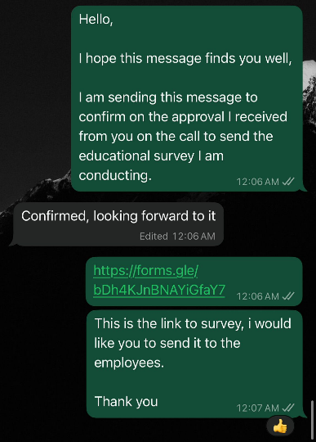

Link: https://forms.gle/bx5iedpDkpRffwiYA
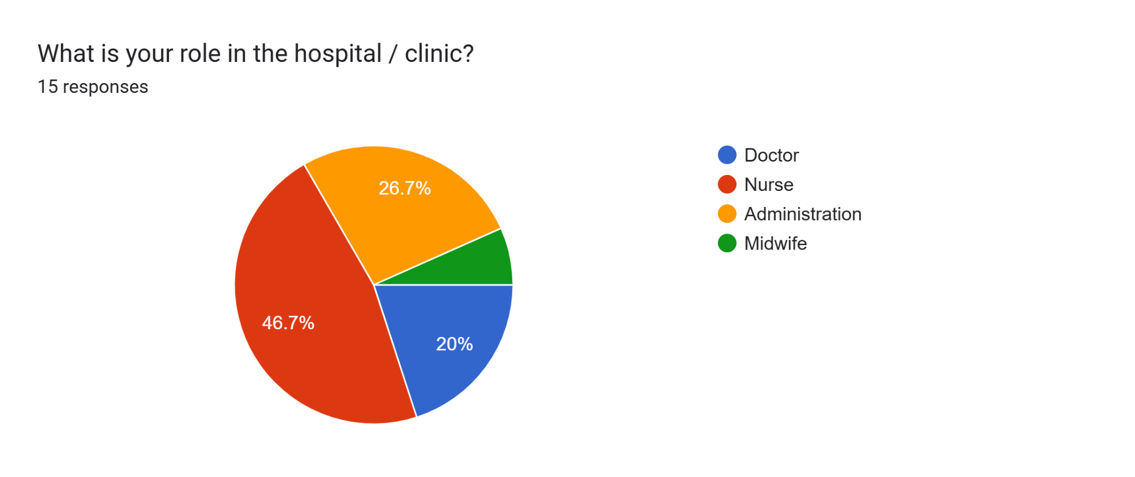
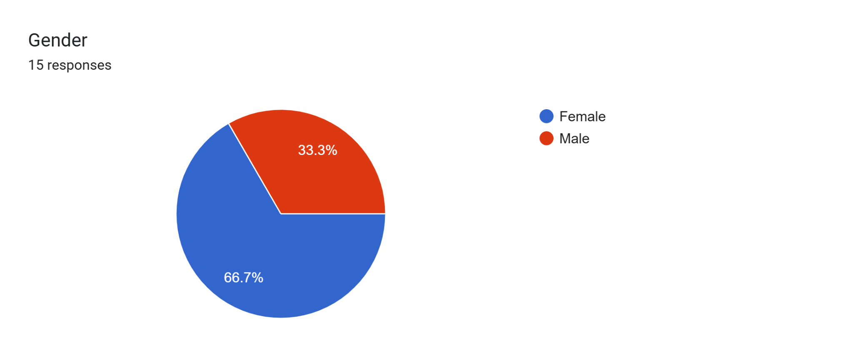
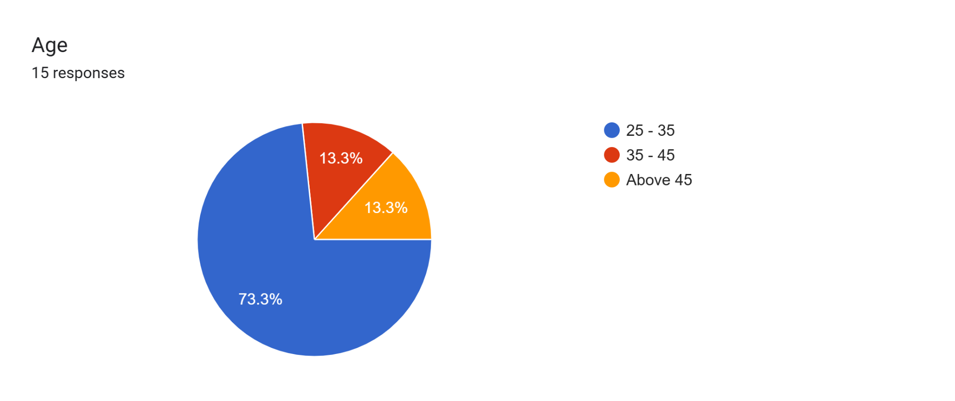
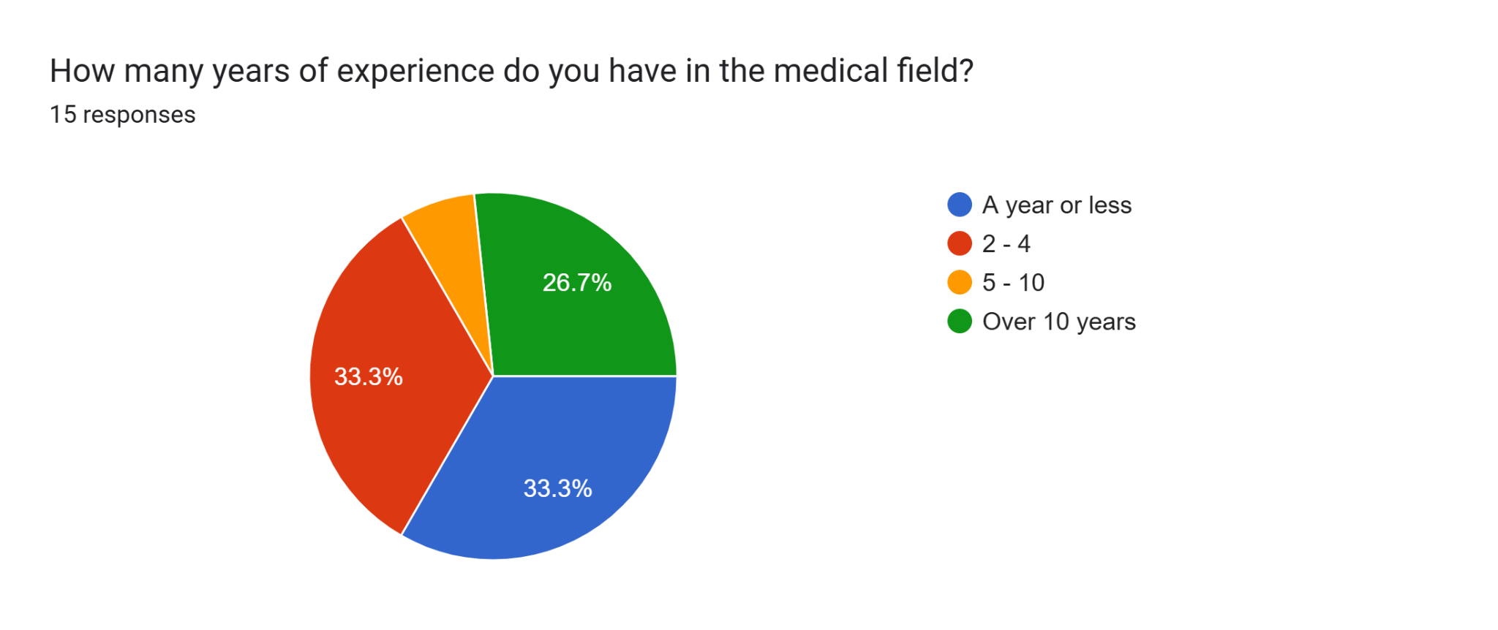
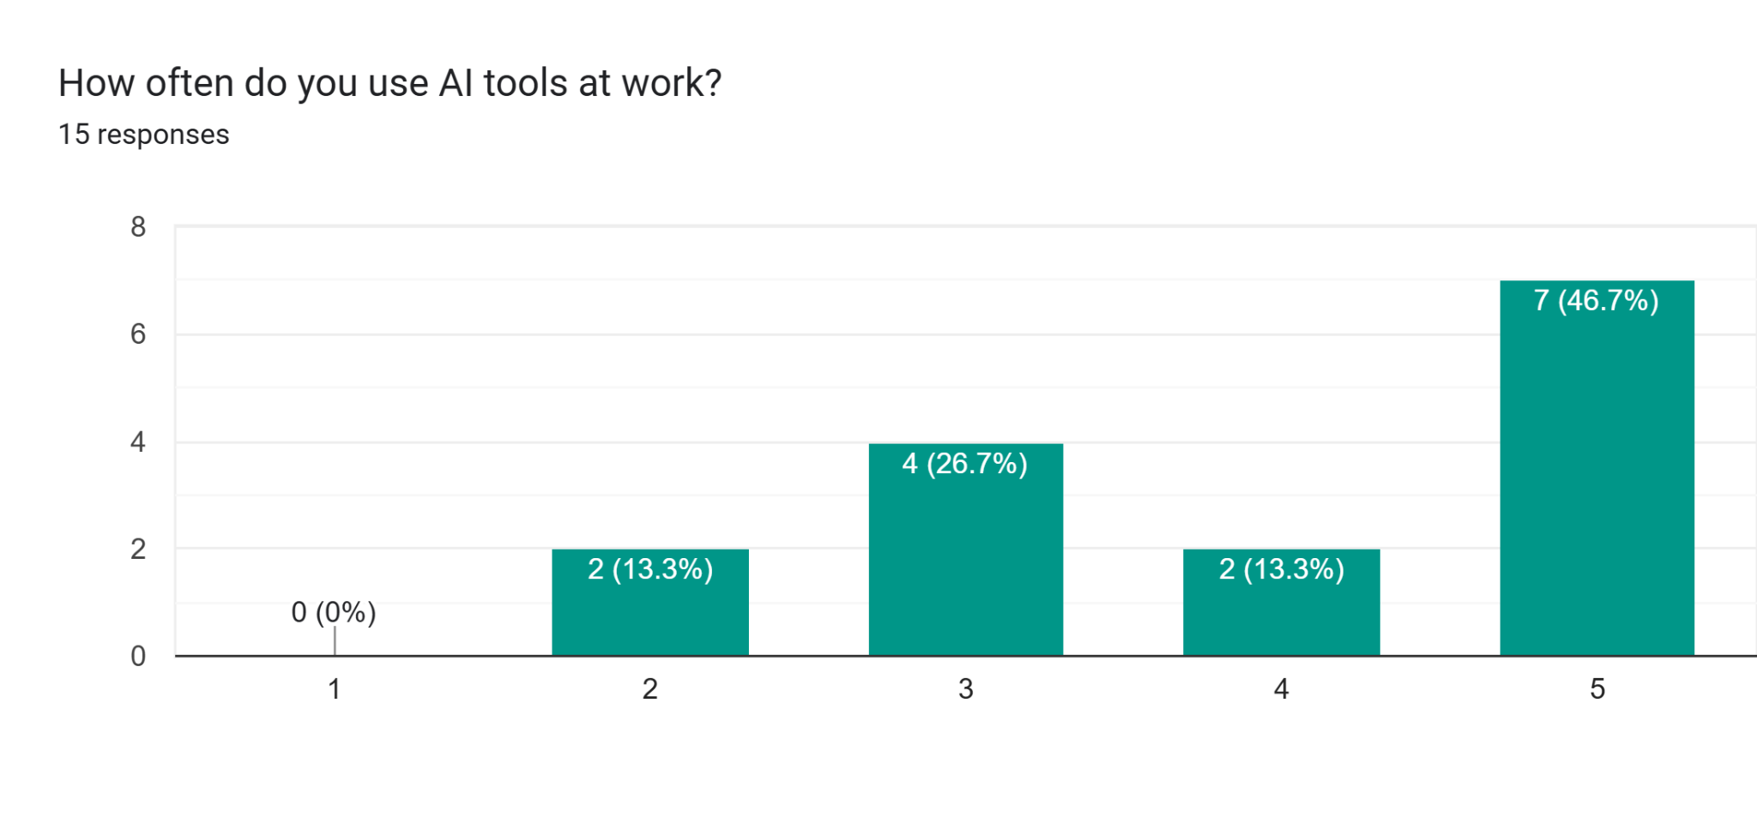

If yes, what AI do you use and what for?6 responses
Data analysis and dashboard
I use Ai websites to get inspired and to nake sure that my informations are correct
I dont use AI
Ai scheduling
Scudeal
Basic information out of curiosity

